http://media.nord.no/PublishingImages/Grafisk/epost-logo-norsk.jpg

**Plagiarism Assessment Guide**

*(This guide applies from 01.04.20)*

This is a guide for subject teachers/examiners in assessing plagiarism or cheating. The guide has been developed to:

* Help identify plagiarism or cheating
* Provide information about the tools we have to detect plagiarism
* Explain how the plagiarism report in the Urkund text recognition system is structured
* Provide information about what the subject teacher/examiner must do if he/she suspects cheating or plagiarism.

Through teaching, information at nord.no and available resources at the University Library, Nord University will facilitate students in acquiring knowledge in relation to the rules concerning academic integrity and referencing. Lack of knowledge about the rules for use of sources, permitted examination aids, guidelines for examinations, or the like, do not relieve the student of accountability for acts of cheating or attempts to cheat. See [chapter 9 of the Regulations relating to studies and examinations at Nord University](https://www.nord.no/en/about/rules-regulations/Documents/Regulations-relating-to-studies-and-examinations-at-Nord-University-revised.pdf) for more information about cheating and plagiarism.

**What is plagiarism?**

Plagiarism can be defined as presenting the published or unpublished work of others as one’s own without satisfactory referencing. Plagiarism is also defined as presenting one’s own published or unpublished work as something new without satisfactory referencing. Plagiarism may be detected by a subject teacher/examiner, or by a text recognition system (plagiarism checker). The text recognition system shows the percentage of text similarity, but does not take into account whether referencing has been conducted in the correct manner. It is not considered plagiarism if a high percentage of text similarity is detected but referencing has been conducted in the correct manner. However, the academic independence of the work will be assessed and reflected in the setting of the grade. If a high percentage of text similarity is detected without referencing being conducted in the correct manner, the subject teacher/examiner must conduct further investigation in order to detect possible plagiarism.

**Assessing whether plagiarism has taken place**

The subject teacher/examiner should assess the following:

* Does the plagiarism checker indicate text similarity? To what extent?
* Has referencing been conducted in the correct manner?
* Is the reference list correct, is it missing sources or have sources been listed that haven’t been used?
* How similar is the submitted text to the source?
* Are there style breaches, or does the text show changes in diction or format?
* Does the text seem familiar?
* Is there evidence of different quotation styles, or lack of quotation marks?
* Does the text show signs of widely varying academic quality?

This list is not exhaustive – the subject teacher/examiner may also detect other signs of plagiarism or cheating by virtue of their academic competence and experience.

If text similarity exceeds 20%, or individual matches result in more than 10%, the examiner must assess the plagiarism report and the use of sources, source referencing and the reference list. A matching content percentage below 20% does not mean that plagiarism hasn’t taken place.

Certain forms of collaboration between students are permitted during individual home examinations. Such collaboration may include discussion of issues, interpretation of the examination question, or the exchange of ideas regarding literature. Any discussions during the work may also be relevant, but the answer itself must be produced by the individual candidate alone, and transcripts or copying are not permitted.

If two or more answers are essentially very similar in terms of content and structure, language, academic views, any misunderstandings and errors, source referencing etc, this may be evidence of prohibited collaboration, which may be considered cheating or attempted cheating.

**Plagiarism checker**

Nord University uses Urkund plagiarism checker on all text documents that are submitted to the Inspera examination system. The Section for Examinations and Diplomas activates the plagiarism checker in Inspera. Urkund plagiarism checker may also be used on submissions in Canvas, but it must be activated by the person who creates the task – in most cases, the subject teacher. In suspected cases, it is also possible to investigate plagiarism in individual tasks by uploading a file directly to Urkund.

**The plagiarism checker doesn’t detect everything**

Urkund can find text similarity in open sources on the internet, in Nord University’s task database and in answers that have previously been checked in Urkund. However, Urkund does not find matches in sources that are located in other institutions’ closed databases, text that students have translated from other languages, or images, notes and formulas.

**When using Urkund for the first time**

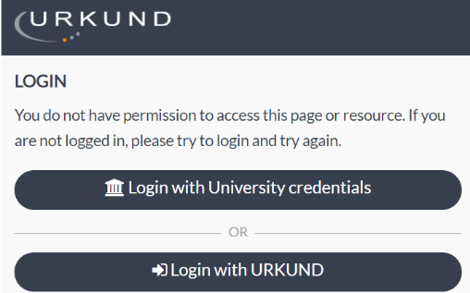When you first open a plagiarism report via Inspera or Canvas, a user is created for you in Urkund. You will see the following image:

Select Login with University credentials and log in using your Feide account.

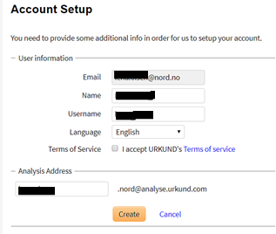

In the next image, you accept Terms of Service and then click on Create.

**How to find the matching content percentage and the plagiarism report**

**In Inspera:** The matching content percentage in a document submitted in Inspera can be found under the Plagiarism Checker tab in the student’s answer paper.

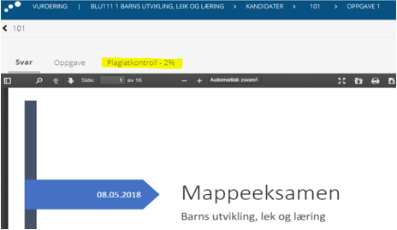

If you want to see the matching content percentage in the next answer paper, use the white arrow key at the bottom of the screen to jump to the next candidate.

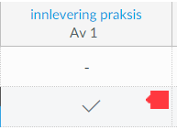**In Canvas:** If you would like to see the matching content percentage in a document submitted in Canvas, you can find the analysis report by opening Karakter/Grades and clicking on the green or red marker next to the submission:

You can also find the matching content percentage in Canvas via Speedgrader:

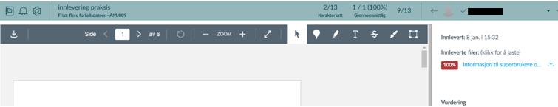

**How to interpret Urkund’s plagiarism report**

This is what the front page looks like. The orange fields at the top of the page show where Urkund has found matching content in the submitted answer.

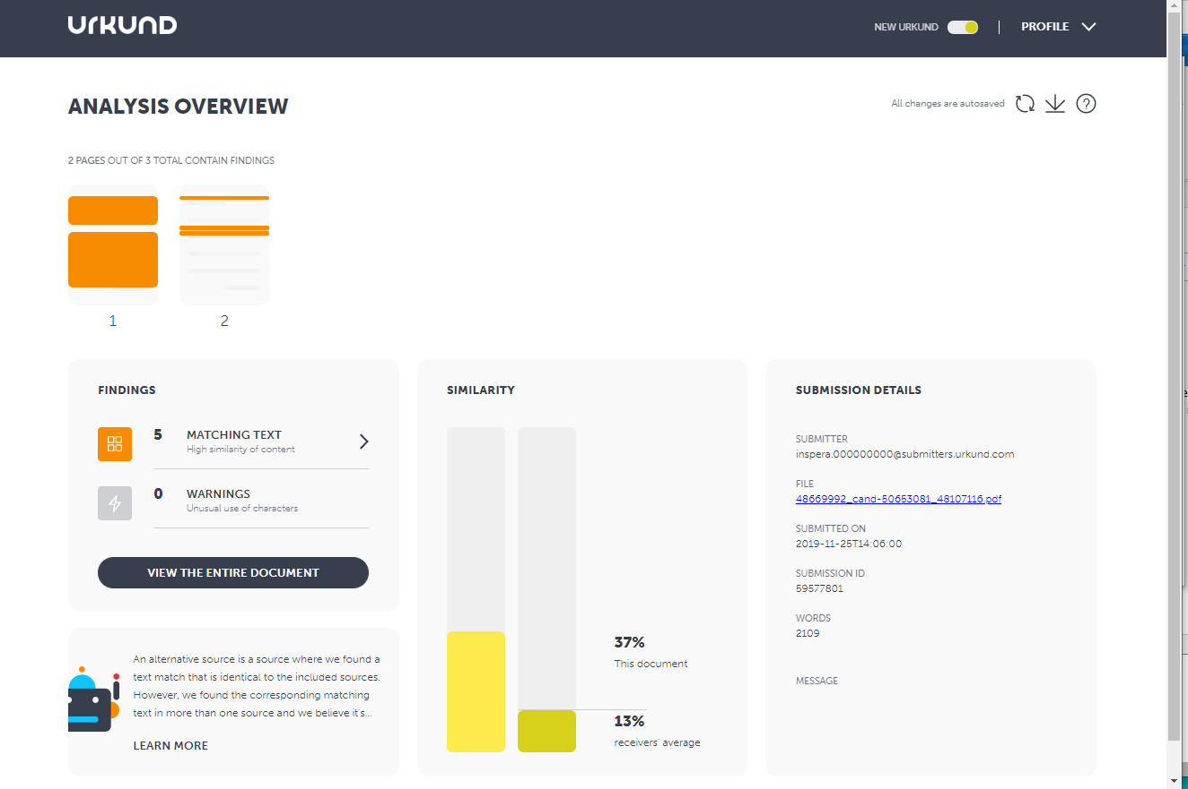

Clicking on MATCHING TEXT on the left-hand side of the image gives you the following analysis:

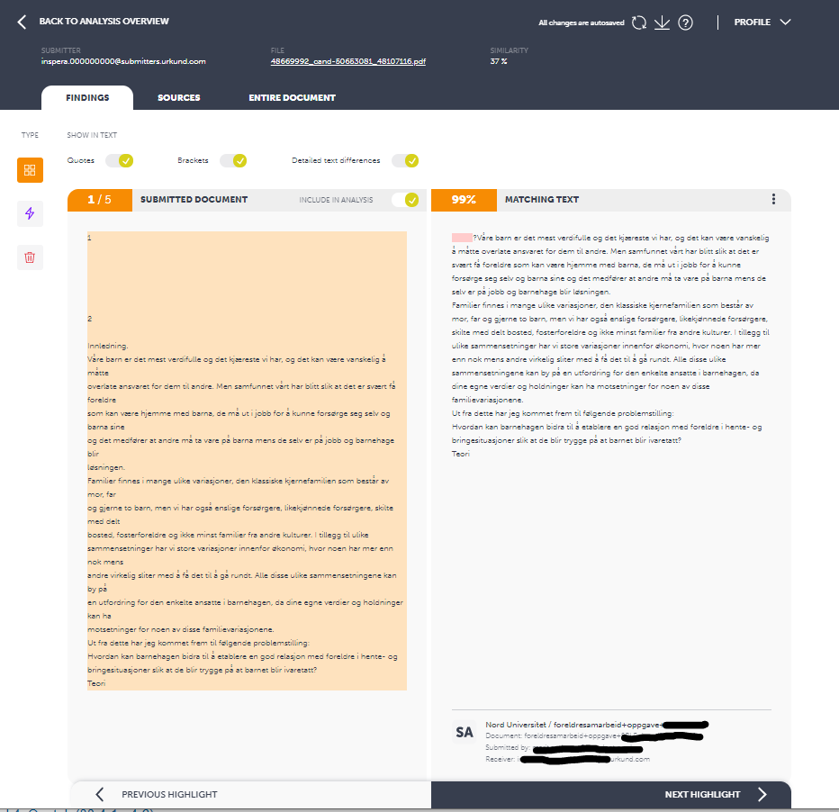

The total percentage of text similarity appears in the blue field at the top of the screen.

The orange field that shows the matching text percentage indicates text similarity for this particular block in the submitted answer.

Text in the checked answer appears in the coloured field on the left-hand side of the image, and text in the ‘source document’ appears in the white field on the right-hand side.

If you select the SOURCES tab at the top of the image, you will get a list of the sources Urkund has found. Here you will see an overview of the matching content percentage in each source, and a link to the relevant source if it is available.

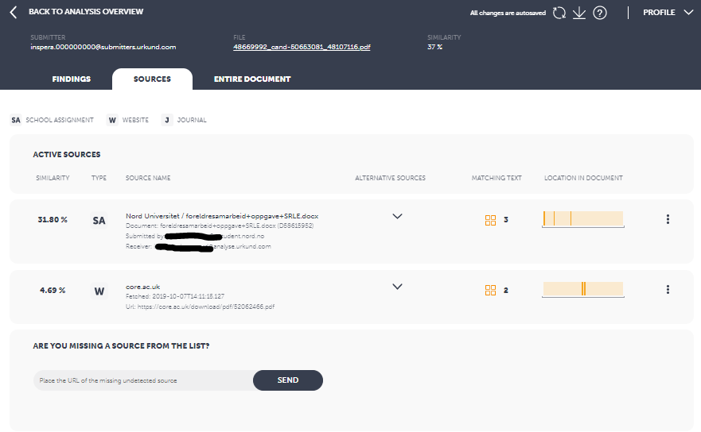

Under ‘Sources’, you will find the matching content percentage for each source, an indication of the type of publication the source belongs to, and an indicator of where the match is located in the answer.

Other sources are displayed under ALTERNATIVE SOURCES. These matches are considered less important by Inspera. Here, you may also choose to hide sources that you don’t want to be part of the total matching content percentage.

You will also receive a link to the relevant source if it is available.

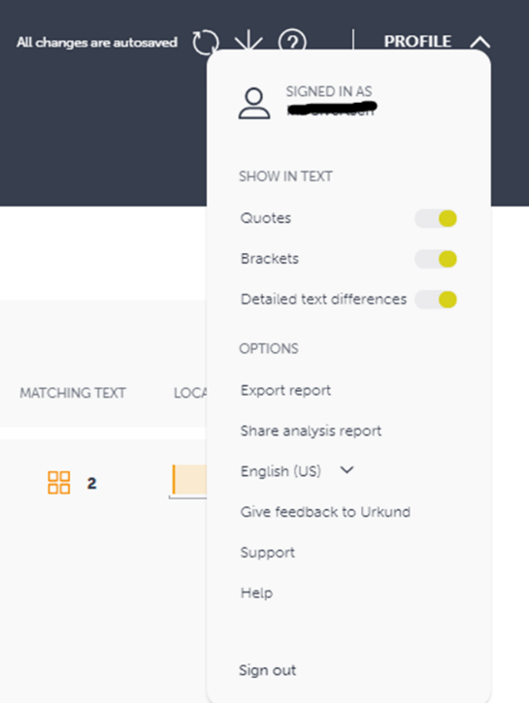**You can share the report with others in the following ways:**

You can send a **link to the report** to colleagues who are Feide users at Nord University.   
Click on Profile and select Share analysis report.   
  
If you wish to share the report with a colleague who isn’t a Feide user at Nord University, you must **send the report as a pdf**. Click on Profile and select Export report

[Here](https://secure.urkund.com/static/manuals/View7_QuickStartGuide_EN.pdf) is a link to Urkund's analysis guide

For more information, see <https://www.urkund.com/>

**Further proceedings if cheating or plagiarism is suspected**

If cheating or plagiarism is suspected in relation to submitted work, the case must be investigated further in order to determine whether official proceedings need to be implemented.

* In cases where cheating or plagiarism is suspected, the subject teacher/examiner must contact the head of the programme of study and the administrative case manager in the Section for Examinations and Diplomas. Together, all three must assess whether official proceedings need to be implemented
* If plagiarism is suspected, the examiner must prepare a document summarising the findings of the plagiarism checker, and highlight in the answer paper where text similarity has been found by the Urkund report and/or other sources.
* The student is called in to a meeting with the examiner/subject teacher, the head of the programme of study and the responsible case manager in the Section for Examinations and Diplomas.
* The student must be made aware of the grounds for suspicion in advance, and is given the opportunity to bring along a person to the meeting, cf. Section 12 of the Public Administration Act.
* The purpose of the conversation is to provide information about the case and provide the student with the opportunity to give their side of the case.
* Students are called in individually if more than one student is involved.
* Minutes from the meeting must be taken. The student is given the opportunity to make a written response to the minutes. The student’s response is attached to the case.

After the meeting with the student has taken place, the examiner, the head of the programme of study and the administrative case manager decide whether the case should be sent to the appeals committee. If the case is sent to the appeals committee, the student must be notified about this in a separate letter. The student is sent a copy of all attachments that are associated with the case.

The Section for Examinations and Diplomas is responsible for submitting the case to the appeals committee. The account of the case that is submitted to the appeals committee must not include recommendations. The appeals committee has an independent duty to investigate, and may ask the student, the faculties and the Section for Examinations and Diplomas for further information.

**Responsible for case management at Nord University:**

An overview of contacts can be found [here](https://norduniversitet.sharepoint.com/Verktoy/studieadministrasjon/Sider/Eksamen-og-sensur.aspx#&acd=e60223e4-484f-9bc5-47e9-b92a03083083).